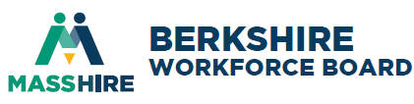
Board of Director Meeting
Thursday, March 5, 2026 8AM Via zoom
Minutes of meeting
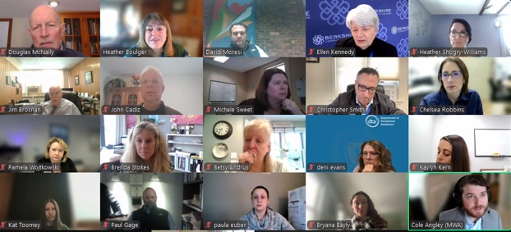
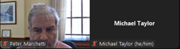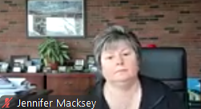
Attendees:
√ | B. Andrus | * | L. Harrison | * | B. Petropulos |  | Staff:
 | T. Billington | * | L. Hernandez |  | A. Rankin | 2 | H. Boulger, H. Williams
* | M. Blake | * | A. Ingegni | √ | C. Robbins | 2 | K.Toomey; B. Malloy
√ | J. Brosnan | √ | E. Kennedy | * | E. Sheridan |  | Guests:
√ | J. Cadiz | √ | K. Kern | √ | M. Sweet |  | Mayor Marchetti
* | E. Dellea |  | J. Maturevich | √ | C. Smith |  | Cole Angley, MWA
√ | P. Euber | √ | D. McNally | √ | B. Stokes |  | Mayor Macksey
√ | D. Evans |  | M. McGeeney | √ | M. Tyler |  | P. Wojtkowski
√ | P. Gage | √ | D. Moresi |  | 15/28
* | T. Gage |  | B. Morrison |  | *excused absence
Mission: To develop partnerships, generate resources, and advocate for workforce solutions that result in a skilled workforce, prospering businesses, and equitable access to meaningful career pathways and quality employment for residents and youth.

- Call to Order
Board President David Moresi started the meeting at 8:01AM by welcoming Board members and welcomed Mayor Marchetti and Cole Angley from Mass Workforce Association, and assuring a quorum (15/28). Self-introduction occurred.

Consent Agenda
President Moresi removed the Individual Training Accounts from the consent agenda and asked if there were any additional items that needed to be removed from the consent agenda. Hearing none, the following items were considered:
- Minutes from proxy December 4, 2025 Board of Directors Meeting.
- FY2026 Financial Statement ($815,975 income; $759,279 expenses; 56,696 net surplus; $129K checking; $152K money market; $75K Accounts Receivable)
Doug McNally made a motion to approve the consent agenda items, seconded by Ellen Kennedy, and the motion carried.
- Individual Training Accounts – 3 providers; 19 programs
Doug McNally made a motion to approve the ITA list, seconded by John Cadiz, and the motion carried. Ellen Kennedy and James Brosnan abstained.

- Announcements/Communications
President Moresi noted the next meeting of the full board of directors
  - Annual Board of Directors Meeting – June 4, 2026 at 8AM in-person, TBD
  - Executive Committee Meeting – April 8th
  - Evaluation Committee Meeting – April 16th at 8AM
  - Youth Council Meeting – April 2nd at 9AM
  - WIOA partners – March 10th at 1PM
  - Spring Orientation – March 16th at 9AM
Communications included:
  - 12/3/25 – FY25 Failed performance Adult Q4 entered employment & credential attainment & Youth credential attainment. Must be 80% - at 65%; 73.7% & 74.8%. Attended training
  - FY2026 Career Center monitoring March 30th -April 4th
  - FY2026 Board monitoring April 13th – 17th

- New Business
FY2026 Nominations Committee – Ellen Kennedy reported that the Board of Directors voted to selection officers every two years in 2024 therefore, there will be nominations for officers for FY27/28. She thanked those who continue to serve. The current officers are:
  - President/Chairperson: David Moresi, Moresi & Associates
  - First Vice President/Chair: Michael Taylor, City of Pittsfield
  - Second Vice President/Chair: Christopher Smith, Hillcrest Educational Centers
  - Treasurer: James Brosnan, Northern Berkshire Vocational School District
  - Asst. Treasurer: Beth Petropulos, MountainOne
  - Secretary: Chelsea Robbins, Mativ
  - At-Large: Albert Ingegni, Salisbury Estates
  - Youth Council Chair: Doug McNally, FrostHollow Associates

The Nomination Committee would like to note that the following Board of Directors are up for reappointment at the June 4, 2026 meeting. Please reach out if there are any concerns with reappointment.
- Monique Blake, Miraval Resort
- James Brosnan, McCann Technical School
- Gene Dellea, Fairview Hospital
- Paula Euber, Massachusetts Rehabilitation Commission
- Linda Harrison, General Dynamics
- Albert Ingegni, Salisbury Estates
- Christopher Smith, Hillcrest Educational Centers
- Michele Sweet, Berkshire Health Systems
- Michael Taylor, City of Pittsfield
- Chelsea Robbins, Mativ

Not Seeking Reappointment:
  - Ellen Kennedy, Berkshire Community College (retire)
Please identify one private-sector leader to recommend to the Board of Directors by May 15th. Also seeking chairperson for Nominations Committee. Please reach out if interested in learning more.

- Massachusetts Workforce Association update
Executive Director Cole Angley highlighted the work of the Association which represents the Massachusetts Workforce Boards and Career Centers. Federal updates included FY27 budget, WIOA Reauthorization, training requirement concerns, and possible redesignation efforts. State updates included FY27 budget priorities of career centers, YouthWorks and School-to-Career Connecting Activities, and the Mass Innovation Project to replace outdated technology, create new case management system, improve customer experiences, and streamline processes & policies. Discussion ensued about budget impacts and potential redistricting.
FY2026 Performance Negotiations – Federal and State guidelines through the Workforce Innovation & Opportunities Act (WIOA) allow regions to negotiate performance based on local needs. The BCREB has accepted all of the FY2026 state goals, however, the Career Center has asked to revisit the WIOA Dislocated Worker Measurable Skills gains. Based on historical data, a realistic local goal of 65% (which is above the state goal of 46% but below the local target of 79.3%). Discussion ensued and James Brosnan made a motion to accept the 65% performance goal. Seconded by Kaylyn Kern, the motion carried.
- Workforce Activities/Program updates
Heather Williams noted that the Youth Council approved the FY27 WIOA Youth Program Procurement on 2/5/26. The current vendor is Berkshire Training & Employment, Inc. and is up for a 1-year contract renewal. The recommendation is no less than 75% of allocation to support Out-of-School Youth program and up to 25% to support In-School Youth programming. The timeline:
- Issuance Date: Friday, February 27, 2026
- Bidders Conference: Tuesday, March 17, 2026 at 10:00 a.m. / zoom
- Q & A deadline: Friday, April 24, 2026
- Proposals Due: Friday, May 1, 2026 at noon
- Evaluation Period: May 4 – May 29, 2026 (PR Team meet on Friday 5/29)
- Notice of Awards: by Monday, June 8, 2026 (Award approval at 6/4/26 BOD Mtg.)

Heather Boulger reported on resources that have been generated since the December Board meeting:
  - $198K GROW Early Childcare Education Apprenticeship grant. MassHire, BCC, YMCA, Gladys Allen Brigham Center, KidZone, Berkshire Head Start
  - $75K Youth Pilot to expand paid youth employment
  - DESE MassStep for Northern Berkshire Adult Education for Culinary Arts Program & new Nursing Assistant program for adult learners
  - EOLWD 2nd Street Re-Entry Adv. Manufacturing Program ($89K)
  - EOLWD BCArc Pilot Employment Program ($80K) for young adults
  - DIA Safety grants to Mass MoCA ($5K/180 employees); 18 Degrees ($6,433/120 employees & Berkshire County Head Start ($3,715/46 employees)
  - Provided several support letters to BIC and BCC for sector training
Provided CNA testing through our Hillcrest Education Foundation donation for Taconic’s Allied Health program

The Manufacturing grant is providing up to 12 On-the-Job Training (OJTs) to manufacturing companies that hire long-term unemployed. Currently, 4 companies are providing 7 OJTs. FY20-FY25 shows that 10 companies provided 57 OJTs. Heather Boulger shared a success story with Jabias, who went through the McCann Adv. Manufacturing program in 2022, was hired by Interprint, and is still employed as a junior printer. Another success was Kaela who was part of our 2023 McCann’s welding program, hired by Lenco, and recently participated in BCC’s leadership program.

Marketing efforts included the monthly workforce Berkshire Eagle article, several interviews, social media highlights, and presenting at Southern Berkshire Chamber of Commerce and BIC. The BCREB FY25 annual report was distributed to the 32 Berkshire communities. As part of celebrating America’s 250th birther, BCREB is posting a weekly Berkshire social media post highlighting workforce innovations.

Bryana Bayly presented the Healthcare Hubs 3-year grant outcomes showing 359 enrolled with an 85% completion rate. Total employed is 195 (64%) which is consistent with grant benchmarks & goals. 2026 enrollment goals include:
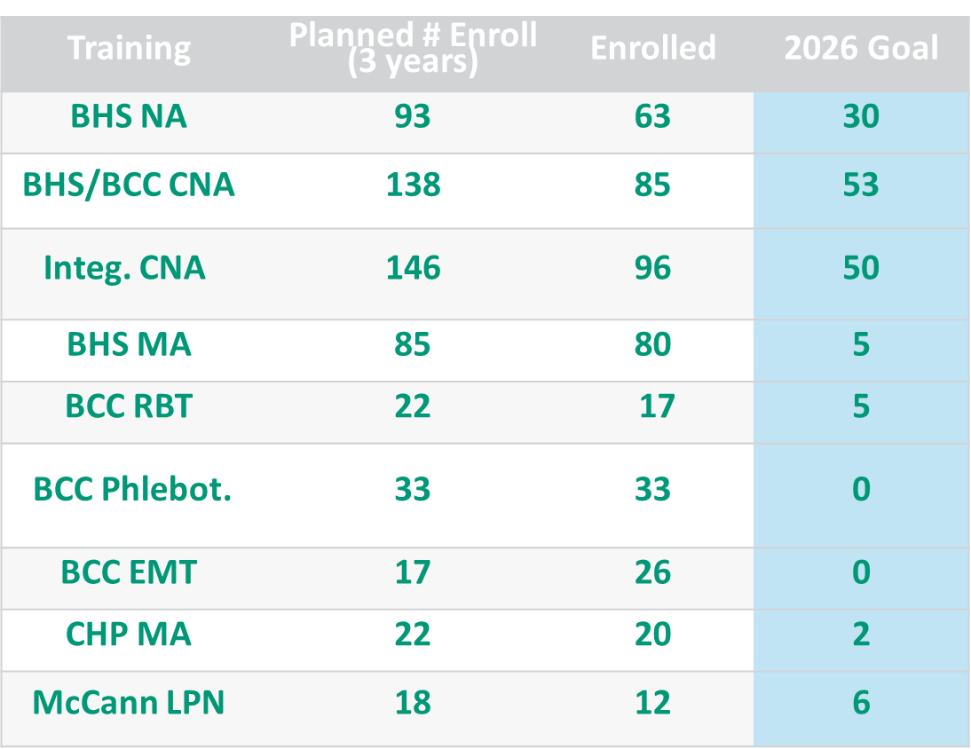

BCREB is providing marketing, outreach, and screening interviews for the Career Technical Initiative (CTI). McCann’s programs include Auto Technician (30 applicants; 12 enrolled); Advanced Manufacturing Technician (27 applicants; 12 enrolled); and Welding (65 applicants, 12 enrolled). Taconic programs include Landscaping (23 applicants/ 10 enrolled).

Looking ahead, BCREB applied for a $100K grant with Jobs for the Future, Advancing AI-Resilient Early-Career Pathways. If funded, the pilot project in collaboration with the BIC and ThriveIEP would be a 10-week training for 60 hours geared towards those ages 18-24. BCREB is also submitting a Donnely Workforce Success Grant to continue medical assistant and nursing assistant training with Integritus and Berkshire Health Systems.

Youth Director Report – Heather Williams reported quarterly youth activities:
- 130 internships (awaiting paperwork from schools noting 50+ internships)
  - 38 paid / 89 unpaid / 3 subsidized
  - $199,528 in wages generated
  - 78 host employers
  - 10 CTE
  - 12 Innovation Pathways / 3 Early College Pathways
- Industry Representation (critical/emerging sectors):
  - 11 Business / Finance
  - 8 Building Trades
  - 8 Culinary/Hospitality
  - 30 Education / Childcare
  - 16 Healthcare / Human Services
  - 1 Manufacturing
  - 40 STEM
- Career Awareness, Exploration & Immersion Activities
  - Hoosac Valley Mock Interviews – December 12th
  - Monument Mountain Internship Expo – January 12th
  - BART Charter Mock Interviews – January 15th
  - Reid Career Fair – February 4th
  - Hoosac Valley Reality Fair & Career Speakers – February 26th
- Innovation Pathway Updates (13 current pathways)– Provides an industry overview, credentials, post-secondary coursework, work-based learning, work-based-learning and career exploration within critical industry sectors.
  - Drury – Healthcare & Social Assistance
  - Hoosac – Environmental / Healthcare & Social Assistance
  - Lenox – Healthcare & Social Assistance / Business & Finance
  - Monument – Adv. Manufacturing / Healthcare & Social Assistance / Business & Finance
  - Mt. Evertt – Information / Adv. Manufacturing /Clean Energy
  - Pittsfield High – Business & Finance / Adv. Manufacturing
- Applying for state designation in 2026:
  - Hoosac – Clean Energy
  - Lenox – Environmental
  - Wahconah – Healthcare & Social Assistance
- BCREB, Ethos Pathways, MassYouthInnoLab Partnership grant from MA Clean Energy Center to support middle school pathways in Clean Energy at Hoosac and Mt. Everett
- YouthWorks learning communities grant - $75K, ¼ regions in the state to enhance the number of employer-paid/sponsored summer YouthWorks opportunities. Hired Marianthy to work with Career Center to reach out to employers. Hired Romelo a Taconic High School sophomore to help with marketing our employer engagement strategy.
- Jobs4 Youth Campaign will be kicking off in March/April

MassHire Berkshire Career Center Report – Pamela Wojtkowski highlighted career center activities:
- WIOA Adult enrolled 19; 10 in training; 4 placed at an average wage of $27/hr
- WIOA Dislocated Worker enrolled 41; 2 in training; 19 employed at average wage of $23.42/hr
- Youth enrolled 20; 5 HiSET; 2 in training, 28 youth pending enrollment
- UI Navigational Assistance assisted 618 customers
- RESEA (Reemployment Services & Eligibility Assessment) – 900 completed with 48 reporting returned to work
- Veterans served 98 with 17 entered employment
- Total customers served 2,823 with 7,742 visits
- Upcoming events:
  - Jain Americas, Inc Recruitment February 25 l 1pm – 3pm l MassHire Career Center
  - Spring Multi-Industry Job & Resource Fair March 26 l 10am – 12pm l Holiday Inn
  - Young Adult Employer Engagement Session April 1 l 10am l Held Virtually
  - CDL Job Fair – Private Event April 3 l 10am – 12pm l MassHire Career Center
  - Young Adult Job Fair (14-25) April 22 l 10am – 12pm l Berkshire Innovation Center
  - 2nd Chances Job Fair April 29 l 12pm – 2pm l Berkshire Innovation Center
- Business Services assisted 924 companies with 260 being new to the center and 664 repeat business with 75 recruitments and 894 marketing efforts.

- Strategic Discussion
Board members discuss updates, challenges and workforce trends. None noted.

- Adjournment
President Moresi thanked Board Members and staff for their continued commitment and hard work. The next meeting of the full Board will be June 4, 2026 at 8AM in person. With no further business to discuss, a motion to adjourn was made by Ellen Kennedy, seconded by Doug McNally, and unanimously approved. Meeting ended at 9:02AM.

Respectfully submitted, Chelsea Robbins, Secretary HPB

