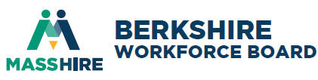
Board of Director Meeting
Thursday, June 4, 2026 8AM
Hillcrest Educational Centers, 788 South Street, Pittsfield, MA 01201
Minutes of meeting
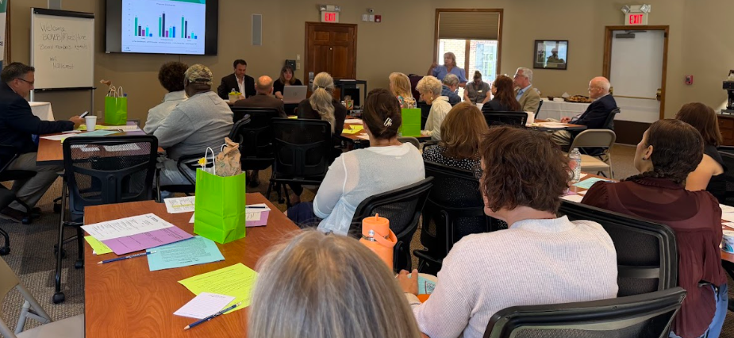
Attendees:
Mission: To develop partnerships, generate resources, and advocate for workforce solutions that result in a skilled workforce, prospering businesses, and equitable access to meaningful career pathways and quality employment for residents and youth.
√ | B. Andrus | √ | L. Harrison | √ | B. Petropulos |  | Staff:
* | T. Billington | √ | L. Hernandez |  | A. Rankin | 2 | H. Boulger, H. Williams
* | M. Blake | * | A. Ingegni | √ | C. Robbins | 3 | K.Toomey; S. Milano; M. Boyer
√ | J. Brosnan | √ | E. Kennedy | √ | E. Sheridan |  | Guests:
√ | J. Cadiz | √ | K. Kern | √ | M. Sweet |  | Mayor Marchetti
* | E. Dellea |  | J. Maturevich | √ | C. Smith | 3 | HHVS educators
√ | P. Euber | √ | D. McNally | √ | B. Stokes | 3 | Romelo’s family
√ | D. Evans | √ | M. McGeeney | * | M. Tyler |  | P. Wojtkowski
* | P. Gage | √ | D. Moresi |  | 19/28 |  | Onyx, Rae Noyes
√ | T. Gage |  | B. Morrison |  | *excused absence |  | Rachel Boilard, BHS Youth Council

- Call to Order
Board President David Moresi started the meeting at 8:02AM by welcoming Board members, Mayor Marchetti and guests, and assuring a quorum (19/28). Chris Smith welcomed everyone to Hillcrest Educational Centers.

Consent Agenda
President Moresi removed the Individual Training Accounts from the consent agenda and asked if there were any additional items that needed to be removed from the consent agenda. Hearing none, the following items were considered:
- Minutes from March 5, 2026 Board of Directors Meeting.
- FY2026 Financial Statement ($1,112,696 income; $1,112,513 expenses; $183 net surplus; $55,189K checking; $152K money market; $37,504K Accounts Receivable)
Ellen Kennedy made a motion to approve the consent agenda items, seconded by Doug McNally, and the motion carried.
- Individual Training Accounts – 4 providers; 6 programs
Tammy Gage made a motion to approve the ITA list, seconded by John Cadiz, and the motion carried. Ellen Kennedy, James Brosnan and Brenda Stokes abstained.

President Moresi asked the Board to consider 2 business items:
403B Recommendation – Current provider is TIAA-CREF. Procured retirement plan service from Principal, Fidelity, Empower, & Voya. Discussion ensued and Ellen Kennedy motioned to approve Principal Insurance as the provider, Janney Retirement as the service provider, and Metro Benefits as the third party administrator. Seconded by Doug McNally, the motion carried. The Executive Director will work with all parties over the summer to make the transition.

Information Technology provider – Current provider is Sourcepass (formerly CompuWorks). Procured IT services from Revolution MSP, Sourcepass, and Synagex. A motion was made by Doug McNally to approve Revolution MSP, seconded by Beth Petropulos, and unanimously passed. The Executive Director will work will all parties to transition services no later than 7/31/26 when the current contract expires.

- Announcements/Communications
President Moresi noted the next meeting of the full board of directors
  - Quarterly Board of Directors Meeting – September 3, 2026 at 8AM via Zoom
  - Executive Committee Meeting – August 12, 2026 at 8AM via Zoom
  - Evaluation Committee Meeting – summer reviews; meeting September 16th at 8AM via Zoom
  - Youth Council Meeting – summer reviews; meeting October 8th at 9AM via Zoom
  - Healthcare Job Fair – June 12th from 10-12PM at Career Center
Communications included:
  - Board & Career Center FY26 monitoring completed and certified
  - Open Meeting Law – remote meetings expires 3/31/27 unless action is taken
  - State Ethics Commissions’ new conflict of Interest Law Online Training every 2 years (Board members can submit certificate from other organizations).

- New Business
FY2026 Nominations Committee Report – Ellen Kennedy welcomed FY26 new Board members Brenda Stokes from MCA; Libby Hernandex from DCS; and Maureen McLaughlin from MillTown, and noted that Dr. Hara Charlier will be replacing her on the Board.

The Nomination Committee would like to recommend the following Board of Directors for a 2-year appointment ending in June 2028:
- Monique Blake, Miraval Resort
- James Brosnan, McCann Technical School
- Gene Dellea, Fairview Hospital
- Paula Euber, Massachusetts Rehabilitation Commission
- Albert Ingegni, Salisbury Estates
- John Maturevic, IUE 254-255
- Amanda Rankin, Carr Hardware
- Christopher Smith, Hillcrest Educational Centers
- Michele Sweet, Berkshire Health Systems
- Michael Taylor, City of Pittsfield
- Chelsea Robbins, Mativ

The following are not seeking reappointment:
- Terri Billington, General Dynamics
- Linda Harrison, General Dynamics
- Ellen Kennedy, Berkshire Community College

Youth Council Members to be re-elected for 2-years ending in June 2028:
- Rebecca Ringer, PALC
- Vin Marinaro, BBE
- Monique Blake, Miraval
- Courtney Warren, BHS
- Bill Ballen, Berk12

Resignation: Kathleen Phillips, Elder Services

Nominations for Officers for two-year term ending June 2028:
  - President/Chairperson: David Moresi, Moresi & Associates
  - First Vice President/Chair: Michael Taylor, City of Pittsfield
  - Second Vice President/Chair: Christopher Smith, Hillcrest Educational Centers
  - Treasurer: James Brosnan, Northern Berkshire Vocational School District
  - Asst. Treasurer: Beth Petropulos, MountainOne
  - Secretary: Chelsea Robbins, Mativ
  - At-Large: Albert Ingegni, Salisbury Estates
  - Youth Council Chair: Doug McNally, FrostHollow Associates

A motion to approve the Nomination Committee report was made by Doug McNally, and seconded by Eva Sheridan. Shelly Sweet amended the motion to replace Courtney Warren (out on leave) with Rachel Boilard from Berkshire Health Systems on the Youth Council. With no objection, the motion carried. David Moresi thanked Ellen Kennedy for her 14 years on the Board/Executive Committee, for chairing the Skills Cabinet, for launching new workforce programs, building community partnerships, and for her commitment to excellence. Heather Boulger thanked Linda Harrison for her 8 years on the Board and community engagement.

- Annual Business
President Moresi asked everyone to complete the required annual conflict of interest and ethical statement.

FY2027 Budget, Calendar & Holiday Schedule – Heather Boulger reviewed the FY2027 budget which is reduced by 20%. Total income anticipated of $1,104,000; expenses of $1,103,500, showing a net surplus of $500. This includes staff salary and technology increases, and a reduction in healthcare training (grant expires in December 2026). Most state line items were level funded. Staff are actively looking for grant opportunities. Doug McNally motioned to approve the FY2027 budget, seconded by Ellen Kennedy, the motion carried.

FY2027 Board meetings –
- September 3, 2026 Via Zoom
- December 3, 2026 In-person
- March 4, 2027 Via Zoom
- June 3, 2027 In-person
The FY2027 holiday schedule was distributed.

FY2027 WIOA Plan – The issuance for FY2027 has not been issued yet, however, the Executive Committee asked for preliminary approval.
- No FY2027 WIOA programmatic, infrastructure or organizational changes anticipated
- Career Center location at 160 North Street, 3rd Floor, Pittsfield, MA
- Board to receive up to 8% of WIOA funds
- Training Threshold request at 20%
- Performance negotiations as needed
Jim Brosnan motioned to submit the plan with the above information when the issuance is released. Seconded by Eva Sheridan, the motion carried.

FY2027 Youth Provider - Heather Williams noted that the FY27 WIOA youth procurement was conducted and there were two in-school youth applicants. The Youth Council is recommending that $209,241 be provided to BTE to serve 21 youth and $46,259 to BTE for Framework & follow-up service, and Hoosac Valley High School to receive $33,548 to serve four youth and 18 Degrees to receive $35,710 to serve five youth. All contingent on the allocation which has not been received yet. A motion to approve the recommendation was made by Ellen Kennedy, seconded by Kaitlyn Kerns, and the motion carried.

Executive Director report included the following updates:
- Visit from EOLWD Undersecretary & EOE Assistant Secretary
- Annual monitoring completed with no findings
- Increased FY26 funding by 20% and programs by 15%
- Recruiting for new Early Childcare Educator Apprenticeships
- Provided social media posts for Countdown to 250 celebration highlighting Berkshire County innovators
- MassHire advocacy and statewide participation on several committees
- Legislative outreach
- Sara Milano reported there were 9 companies providing on-the-job training to 15 new employees
- Highlighted teacher appreciation week
- Healthcare grant showed 405 enrolled, with 375 completing and 247 employed
- Career Technical Initiative grant showed 3 programs at McCann with 36 enrolled and 28 completing. Taconic provided Landscaping (12 enrolled with 9 completing). Tammy Gage indicated that there were two additional programs – welding with 10 completing and Autobody with 9 completing.
- Grant submissions with AI early-Career Pathways with Jobs for the Future; WCTF/Donnelly healthcare grant; and Community Workforce Partnership program for hospitality training.
- Berkshire Skills Cabinet convened and reviewed Berkshire Blueprint 3.0

Youth Director report included:
- FY26 Connecting Activities - $334,438 provided teams to integrate career readiness schoolwide
- 330+ internships; 75+ career activities. Thank you Board members for participating!
- 15 Innovation Pathways (3 new at WRHS/Healthcare; Lenox/Environmental; & Hoosac/Clean Energy
- Summer programming – YouthWorks – 50 youth
- North County summer internship for 8-10 youth. Thank you to MountainOne, Beacon Bank, A Better Community, First Congregational Church of Williamstown, & MCLA!
- YouthWorks Learning Communities Pilot – 40 employer paid positions
- Young Adult Job Fair on April 22nd with over 100 youth

Doug McNally noted the important impact of BCREB staff on these programs and how they are viewed as leaders across the Commonwealth.

- Mayor Marchetti & Workforce Impact Awards.
Mayor Marchetti thanked the Board and staff for their dedication and leadership during FY26, and noted that the City of Pittsfield values its partnership with MassHire in helping employers attract, retain, and develop a strong workforce. He charged the Board with engaging the 32 communities in the region to help bring people together, solve problems, and create opportunities.

Heather Williams presented Romelo Holley from Taconic High School with the 2026 Outstanding Youth Award.

Beth Petropulos presented Kristen Palatt, Erica Girgenti, & Lindsay McGinnis from Hoosac Valley Middle/High School with the 2026 Educational Leaders Award.

James Brosnan presented Sara Milano from BCREB with the 2026 Workforce Professional Award.

Christopher Smith presented Rae from Onyx with the 2026 Employer of the Year award.

MassHire Berkshire Career Center Report – Pamela Wojtkowski highlighted career center activities:
- WIOA Adult enrolled 20; 13 in training; 6 placed at an average wage of $27/hr
- WIOA Dislocated Worker enrolled 48; 14 in training; 19 employed at average wage of $23.42/hr
- Youth enrolled 37; 6 HiSET; 13 in training, 7 youth job placed.
- UI Navigational Assistance assisted 1,418 customers
- RESEA (Reemployment Services & Eligibility Assessment) – 769 completed with 48 reporting returned to work
- Veterans served 126 with 24 entered employment
- Total customers served 3,805 with 11,526 visits
- Upcoming events:
  - Cori training workshop
  - Jain Americas Recruitment
  - CTI McCann welding recruitment
  - CTI Taconic Landscaping recruitment
  - Healthcare Hubs-Nursing Assistant recruitment
  - AI Introduction workshop
  - Young adult job fair
  - Fair changes job and resources fair
  - Annual spring job fair – 139 jobseekers and 47 employers
  - Healthcare job fair on June 12th
- Business Services assisted 1,002 companies with 311 being new to the center and 691 repeat business with 120 recruitments and 956 marketing efforts.

- Strategic Discussion
Board members discuss updates, challenges and workforce trends. None noted. Board members to complete SWOT analysis and return to staff. Board members discussed the longevity of the BCREB team and stability of leadership.

- Adjournment
President Moresi thanked Board Members and staff for their continued commitment and hard work, and thanked Mayor Marchetti and guests for attending. The next meeting of the full Board will be September 3, 2026 at 8AM via zoom. With no further business to discuss, a motion to adjourn was made by Ellen Kennedy, seconded by Eva Sheridan, and unanimously approved. Meeting ended at 9:10AM.

Respectfully submitted, Chelsea Robbins, Secretary HPB

