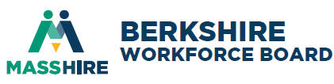
Berkshire WIOA Partners Meeting
Tuesday, May 10, 2026
1:00-2:00PM

Join Zoom Meeting
https://us02web.zoom.us/j/84307408843?pwd=th2Xb0ZIWpB6t9ltw1X21ApW7wcDka.1
Meeting ID: 843 0740 8843 Passcode: 228661

Working to support a seamless system of workforce and education services that builds career pathways for individuals and leads to a more informed, educated, and skilled workforce that meets the needs of Berkshires’ businesses’ demands and sustains a thriving and diverse labor force.
AGENDA

- Welcome and Introductions

Required partners: WIOA Adult, Dislocated Worker & Youth (Title I);

Adult Education (Title II)

Wagner-Peyser (Title III)

Vocational Rehabilitation

DUA

Trade

Veterans

TANF & SNAP

SCSEP

ExOffender Program

Additional Berkshire partners: BCAC, McCann, BCC, Berkshire Housing, BHOC & New England Farm Workers Council.

- MOU Priorities
- Shared customer
- Continuum of services (access, case management, data collection, etc.)
- Performance measures

- MassHire Berkshire Updates
- Career Pathway & Grant Opportunities
- Career Center Update

- Partner Updates
  - Information Sharing & Staff Development

V. Next Steps
