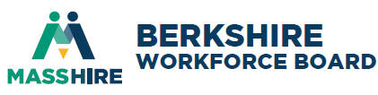
Board of Director Meeting
Thursday, September 4, 2025, 8-9:15AM

Register in advance for this meeting:
https://us02web.zoom.us/meeting/register/ulPsrEW_QdS_uAnTDJy9Sg
After registering, you will receive a confirmation email containing information about joining the meeting.

AGENDA

Call to Order
David Moresi, President/Chairman

I. Consent Agenda (vote) (5 minutes)

A. Minutes of proxy June 5, 2025 meeting
B. FY2025 Audit
C. FY2026 Financial report
D. Individual Training Account

II. Announcements/Communications (5 minutes)
- Next BCREB Board meeting, Thursday, December 4, 2025 at 8:00 AM In Person TBD
- Committee meetings will be announced
- Communications

III. New Business (15 minutes)
FY2026 WIOA Planning
Connecting Activities FY26 Allocations (vote)

IV. Chief Elected Official Comments (10 minutes)
Mayor Peter Marchetti, City of Pittsfield

V. Reports (25 minutes)
Executive Director, Heather Boulger
Youth Director, Heather Williams
Industry Initiatives, Bryana Bayly & Sara Milano
Career Center Report, Pam Wojtkowski

VI. Strategic Discussion (15 minutes)
- FY 2026 Workforce Strategy
- Workforce/Business/Economic Trends
Open Discussion

VII. Adjournment

City and Town Clerks: Please post this notice pursuant to M.G.L., Chapter 39, Section 23B

